**SPRAWOZDANIE**

Zajęcia: Grafika komputerowa

Prowadzący: mgr Mikołaj Grygiel

**Laboratorium 12**

23.06.2024

**Temat:** Grafika 3D w bibliotece WebGL/GLSL

**Wariant**: 1

Radosław Skrzypczyński

Informatyka I stopień,

niestacjonarne,

4 semestr,

Gr. 1B

1. **Polecenie:**

Plik lab12.html pokazuje mały sześcian, który można obrócić, przeciągając myszą na płótnie. Zadaniem jest zastąpienie sześcianu dużym wiatrakiem siedzącym na prostokątnej podstawie, jak pokazano na rysunku 1. Łopatki wiatraka powinny obracać się po włączeniu animacji. Każda łopatka wiatraka powinna być zbudowana z dwóch stożków. (Dodanie czajniczka, który znajduje się na podstawie, jest konieczne dla uzyskania oceny "5").

Program zawiera trzy zmienne instancji reprezentujące podstawowe obiekty: cube, cone, cylinder. Te zmienne mają metody instancji cube.render(), cone.render(), cylinder.render(), które można wywołać w celu narysowania obiektów. Obiekty nietransformowane mają rozmiar 1 we wszystkich trzech kierunkach i mają swój środek na (0, 0, 0). Oś stożka i oś cylindra są wyrównane wzdłuż osi Z. Wszystkie obiekty na scenie powinny być przekształconymi wersjami podstawowych obiektów (lub podstawowego obiektu czajnika).

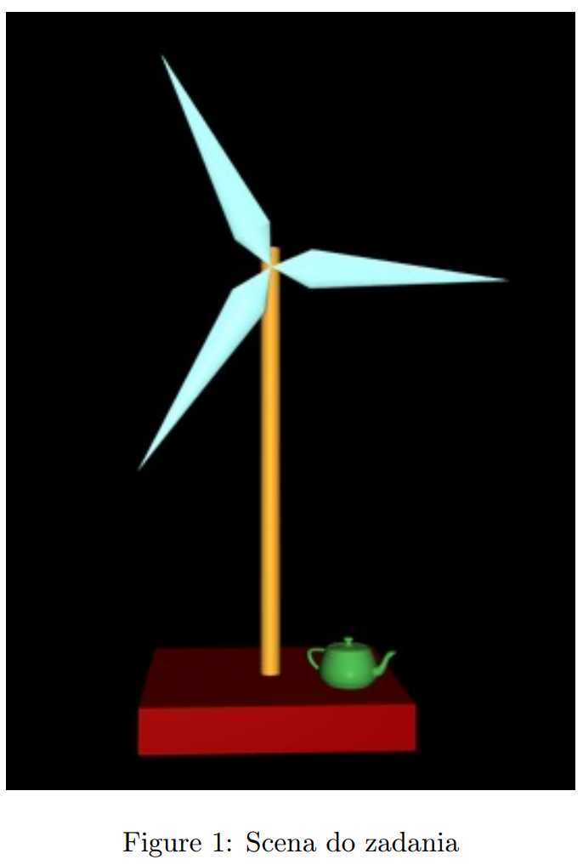

**2. Wprowadzane dane:**

Ruchy myszką służą do obracania obiektu

**3. Wykorzystane komendy:**

Index.html

*<!DOCTYPE html>*

*<meta charset="UTF-8">*

*<html>*

*<head>*

*<title>CS424, Fall 2017, Lab 12</title>*

*<style>*

*body {*

*background-color: #EEEEEE;*

*}*

*label {*

*white-space: pre;*

*margin-left: 25px;*

*}*

*</style>*

*<script type="x-shader/x-vertex" id="vshader-source">*

*attribute vec3 a_coords;*

*attribute vec3 a_normal;*

*uniform mat4 modelview;*

*uniform mat4 projection;*

*varying vec3 v_normal;*

*varying vec3 v_eyeCoords;*

*void main() {*

*vec4 coords = vec4(a_coords,1.0);*

*vec4 eyeCoords = modelview * coords;*

*gl_Position = projection * eyeCoords;*

*v_normal = normalize(a_normal);*

*v_eyeCoords = eyeCoords.xyz/eyeCoords.w;*

*}*

*</script>*

*<script type="x-shader/x-fragment" id="fshader-source">*

*#ifdef GL_FRAGMENT_PRECISION_HIGH*

*precision highp float;*

*#else*

*precision mediump float;*

*#endif*

*struct MaterialProperties {*

*vec3 diffuseColor; // diffuseColor.a is alpha for the fragment*

*vec3 specularColor;*

*vec3 emissiveColor;*

*float specularExponent;*

*};*

*struct LightProperties {*

*bool enabled;*

*vec4 position;*

*vec3 color;*

*};*

*uniform MaterialProperties material; // do two-sided lighting, but assume front and back materials are the same*

*uniform LightProperties lights[4];*

*uniform mat3 normalMatrix;*

*varying vec3 v_normal;*

*varying vec3 v_eyeCoords;*

*vec3 lightingEquation( LightProperties light, MaterialProperties material,*

*vec3 eyeCoords, vec3 N, vec3 V ) {*

*// N is normal vector, V is direction to viewer.*

*vec3 L, R; // Light direction and reflected light direction.*

*if ( light.position.w == 0.0 ) {*

*L = normalize( light.position.xyz );*

*}*

*else {*

*L = normalize( light.position.xyz/light.position.w - v_eyeCoords );*

*}*

*if (dot(L,N) <= 0.0) {*

*return vec3(0.0);*

*}*

*vec3 reflection = dot(L,N) * light.color * material.diffuseColor;*

*R = -reflect(L,N);*

*if (dot(R,V) > 0.0) {*

*float factor = pow(dot(R,V),material.specularExponent);*

*reflection += factor * material.specularColor * light.color;*

*}*

*return reflection;*

*}*

*void main() {*

*vec3 normal = normalize( normalMatrix*v_normal );*

*vec3 viewDirection = normalize( -v_eyeCoords); // (Assumes a perspective projection.)*

*vec3 color = material.emissiveColor;*

*for (int i = 0; i < 4; i++) {*

*if (lights[i].enabled) {*

*if (gl_FrontFacing) {*

*color += lightingEquation( lights[i], material, v_eyeCoords,*

*normal, viewDirection);*

*}*

*else {*

*color += lightingEquation( lights[i], material, v_eyeCoords,*

*-normal, viewDirection);*

*}*

*}*

*}*

*gl_FragColor = vec4(color, 1);*

*}*

*</script>*

*<script src="gl-matrix.js"></script>*

*<script src="basic-object-models-IFS.js"></script>*

*<script src="teapot-model-IFS.js"></script>*

*<script src="index.js"></script>*

*</head>*

*<body onload="init()">*

*<h2>DiskWorld 2: WebGL Lighting and Hierarchical Modeling</h2>*

*<noscript>*

*<hr>*

*<h3>This page requires Javascript and a web browser that supports WebGL</h3>*

*<hr>*

*</noscript>*

*<p id="message" style="font-weight:bold">Drag your mouse on the model to rotate it.</p>*

*<p>*

*<label><input type="checkbox" id="animCheck">Animate</label>*

*<button id="reset" style="margin-left:40px">Reset</button>*

*</p>*

*<div>*

*<canvas width=800 height=800 id="webglcanvas" style="background-color:blue"></canvas>*

*</div>*

*</body>*

*</html>*

Index.js

*"use strict";*

*var gl; // The webgl context*

*var canvas; // The canvas where gl draws*

*var a_coords_loc; // Location of the a_coords attribute variable in the shader program*

*var a_normal_loc; // Location of a_normal attribute*

*var u_modelview; // Locations for uniform matrices*

*var u_projection;*

*var u_normalMatrix;*

*var u_material; // An object tolds uniform locations for the material.*

*var u_lights; // An array of objects that holds uniform locations for light properties.*

*var projection = mat4.create(); // projection matrix*

*var modelview = mat4.create(); // modelview matrix*

*var normalMatrix = mat3.create(); // matrix for transforming normal vectors*

*var frameNumber = 0; // frame number during animation*

*var cone, cylinder, cube; // Basic objects, created using function createModel and basic-object-models-IFS.js.*

*// The cube is 1 unit on each side and is centered at (0,0,0).*

*// the cone and cylinder have diameter 1 and height 1 and are centered at*

*// (0,0,0), with their axes aligned along the z-axis.*

*var matrixStack = []; // A stack of matrices for implementing hierarchical graphics*

*var currentColor = [1, 1, 1]; // The current diffuse color; render() functions in the basic objects set*

*// the diffuse color to currentColor when it is called before drawing the object*

*// Specular color properties, which don't change, are set in initGL()*

*var rotateX = 0, rotateY = 0; // Overal rotation of model, in radians, set by mouse dragging.*

*let rotateEachFrame = 0.5;*

*function draw() {*

*gl.clearColor(0, 0, 0, 1);*

*gl.clear(gl.COLOR_BUFFER_BIT | gl.DEPTH_BUFFER_BIT);*

*mat4.perspective(projection, Math.PI / 4, 1, 1, 50);*

*gl.uniformMatrix4fv(u_projection, false, projection);*

*mat4.lookAt(modelview, [0, 0, 25], [0, 0, 0], [0, 1, 0]);*

*mat4.rotateX(modelview, modelview, rotateX);*

*mat4.rotateY(modelview, modelview, rotateY);*

*// Podstawka*

*pushMatrix();*

*currentColor = [0.999, 0.2, 0.3];*

*mat4.translate(modelview, modelview, [0, -5, 0]);*

*mat4.scale(modelview, modelview, [5, 1, 5]);*

*cube.render();*

*popMatrix();*

*// Trzonek*

*pushMatrix();*

*currentColor = [0.5, 0.2, 0.7];*

*mat4.translate(modelview, modelview, [0, 0, 0]);*

*mat4.rotateX(modelview, modelview, Math.PI * 0.5);*

*mat4.scale(modelview, modelview, [0.4, 0.4, 10]);*

*cylinder.render();*

*popMatrix();*

*// Dzbanek*

*pushMatrix();*

*currentColor = [0.440, 0.2, 0.5];*

*mat4.translate(modelview, modelview, [1.0, -4.1, -1.5]);*

*mat4.scale(modelview, modelview, [0.05, 0.05, 0.05]);*

*teapot.render();*

*popMatrix();*

*// Łopatki wiatraka*

*pushMatrix();*

*mat4.translate(modelview, modelview, [-2.9, 2, 0.2]);*

*pushMatrix();*

*mat4.translate(modelview, modelview, [2.9, 2, 0]);*

*mat4.rotate(modelview, modelview, rotateEachFrame, [0, 0, 1]);*

*mat4.translate(modelview, modelview, [2.9, -2, 0]);*

*for (let i = 0; i < 49; i++) {*

*pushMatrix();*

*mat4.translate(modelview, modelview, [-3, 1.95, 0]);*

*mat4.rotateZ(modelview, modelview, i * (360 / 49) * (Math.PI / 180));*

*mat4.rotateY(modelview, modelview, Math.PI);*

*// Pierwszy stożek*

*pushMatrix();*

*currentColor = [50 / 255, 0.5, 40 / 255];*

*mat4.rotateY(modelview, modelview, Math.PI / 2);*

*mat4.translate(modelview, modelview, [0, 0, 3.7]);*

*mat4.scale(modelview, modelview, [0.7, 0.7, 3]);*

*cone.render();*

*popMatrix();*

*// Drugi stożek - lustrzane odbicie*

*pushMatrix();*

*currentColor = [50 / 255, 0.5, 40 / 255];*

*mat4.rotateY(modelview, modelview, Math.PI / 2);*

*mat4.translate(modelview, modelview, [0, 0, -0.7]);*

*mat4.scale(modelview, modelview, [0.7, 0.7, 3]); // Odbicie lustrzane*

*cone.render();*

*popMatrix();*

*popMatrix();*

*}*

*popMatrix();*

*popMatrix();*

*}*

*/\*\**

*\* Push a copy of the current modelview matrix onto the matrix stack.*

*\*/*

*function pushMatrix() {*

*matrixStack.push(mat4.clone(modelview));*

*}*

*/\*\**

*\* Restore the modelview matrix to a value popped from the matrix stack.*

*\*/*

*function popMatrix() {*

*modelview = matrixStack.pop();*

*}*

*/\*\**

*\* Create one of the basic objects. The modelData holds the data for*

*\* an IFS using the structure from basic-object-models-IFS.js. This function*

*\* creates VBOs to hold the coordinates, normal vectors, and indices*

*\* from the IFS, and it loads the data into those buffers. The function*

*\* creates a new object whose properties are the identities of the*

*\* VBOs. The new object also has a function, render(), that can be called to*

*\* render the object, using all the data from the buffers. That object*

*\* is returned as the value of the function. (The second parameter,*

*\* xtraTranslate, is there because this program was ported from a Java*

*\* version where cylinders were created in a different position, with*

*\* the base on the xy-plane instead of with their center at the origin.*

*\* The xtraTranslate parameter is a 3-vector that is applied as a*

*\* translation to the rendered object. It is used to move the cylinders*

*\* into the position expected by the code that was ported from Java.)*

*\*/*

*function createModel(modelData) {*

*var model = {};*

*model.coordsBuffer = gl.createBuffer();*

*model.normalBuffer = gl.createBuffer();*

*model.indexBuffer = gl.createBuffer();*

*model.count = modelData.indices.length;*

*gl.bindBuffer(gl.ARRAY_BUFFER, model.coordsBuffer);*

*gl.bufferData(gl.ARRAY_BUFFER, modelData.vertexPositions, gl.STATIC_DRAW);*

*gl.bindBuffer(gl.ARRAY_BUFFER, model.normalBuffer);*

*gl.bufferData(gl.ARRAY_BUFFER, modelData.vertexNormals, gl.STATIC_DRAW);*

*gl.bindBuffer(gl.ELEMENT_ARRAY_BUFFER, model.indexBuffer);*

*gl.bufferData(gl.ELEMENT_ARRAY_BUFFER, modelData.indices, gl.STATIC_DRAW);*

*model.render = function () { // This function will render the object.*

*// Since the buffer from which we are taking the coordinates and normals*

*// changes each time an object is drawn, we have to use gl.vertexAttribPointer*

*// to specify the location of the data. And to do that, we must first*

*// bind the buffer that contains the data. Similarly, we have to*

*// bind this object's index buffer before calling gl.drawElements.*

*gl.bindBuffer(gl.ARRAY_BUFFER, this.coordsBuffer);*

*gl.vertexAttribPointer(a_coords_loc, 3, gl.FLOAT, false, 0, 0);*

*gl.bindBuffer(gl.ARRAY_BUFFER, this.normalBuffer);*

*gl.vertexAttribPointer(a_normal_loc, 3, gl.FLOAT, false, 0, 0);*

*gl.uniform3fv(u_material.diffuseColor, currentColor);*

*gl.uniformMatrix4fv(u_modelview, false, modelview);*

*mat3.normalFromMat4(normalMatrix, modelview);*

*gl.uniformMatrix3fv(u_normalMatrix, false, normalMatrix);*

*gl.bindBuffer(gl.ELEMENT_ARRAY_BUFFER, this.indexBuffer);*

*gl.drawElements(gl.TRIANGLES, this.count, gl.UNSIGNED_SHORT, 0);*

*if (this.xtraTranslate) {*

*popMatrix();*

*}*

*}*

*return model;*

*}*

*/\*\**

*\* Creates a program for use in the WebGL context gl, and returns the*

*\* identifier for that program. If an error occurs while compiling or*

*\* linking the program, an exception of type String is thrown. The error*

*\* string contains the compilation or linking error. If no error occurs,*

*\* the program identifier is the return value of the function.*

*\* The second and third parameters are the id attributes for <script>*

*\* elements that contain the source code for the vertex and fragment*

*\* shaders.*

*\* If the third parameter is present, it should be the name of an*

*\* attribute variable in the shader program, and the attribute should be*

*\* one that is always used. The attribute will be assigned attribute*

*\* number 0. This is done because it is suggested that there should*

*\* always be an attribute number 0 in use.*

*\*/*

*function createProgram(gl, vertexShaderID, fragmentShaderID, attribute0) {*

*function getTextContent(elementID) {*

*// This nested function retrieves the text content of an*

*// element on the web page. It is used here to get the shader*

*// source code from the script elements that contain it.*

*var element = document.getElementById(elementID);*

*var node = element.firstChild;*

*var str = "";*

*while (node) {*

*if (node.nodeType == 3) // this is a text node*

*str += node.textContent;*

*node = node.nextSibling;*

*}*

*return str;*

*}*

*try {*

*var vertexShaderSource = getTextContent(vertexShaderID);*

*var fragmentShaderSource = getTextContent(fragmentShaderID);*

*} catch (e) {*

*throw "Error: Could not get shader source code from script elements.";*

*}*

*var vsh = gl.createShader(gl.VERTEX_SHADER);*

*gl.shaderSource(vsh, vertexShaderSource);*

*gl.compileShader(vsh);*

*if (!gl.getShaderParameter(vsh, gl.COMPILE_STATUS)) {*

*throw "Error in vertex shader: " + gl.getShaderInfoLog(vsh);*

*}*

*var fsh = gl.createShader(gl.FRAGMENT_SHADER);*

*gl.shaderSource(fsh, fragmentShaderSource);*

*gl.compileShader(fsh);*

*if (!gl.getShaderParameter(fsh, gl.COMPILE_STATUS)) {*

*throw "Error in fragment shader: " + gl.getShaderInfoLog(fsh);*

*}*

*var prog = gl.createProgram();*

*gl.attachShader(prog, vsh);*

*gl.attachShader(prog, fsh);*

*if (attribute0) {*

*gl.bindAttribLocation(prog, 0, attribute0);*

*}*

*gl.linkProgram(prog);*

*if (!gl.getProgramParameter(prog, gl.LINK_STATUS)) {*

*throw "Link error in program: " + gl.getProgramInfoLog(prog);*

*}*

*return prog;*

*}*

*/* Initialize the WebGL context. Called from init() */*

*function initGL() {*

*var prog = createProgram(gl, "vshader-source", "fshader-source", "a_coords");*

*gl.useProgram(prog);*

*gl.enable(gl.DEPTH_TEST);*

*/* Get attribute and uniform locations */*

*a_coords_loc = gl.getAttribLocation(prog, "a_coords");*

*a_normal_loc = gl.getAttribLocation(prog, "a_normal");*

*gl.enableVertexAttribArray(a_coords_loc);*

*gl.enableVertexAttribArray(a_normal_loc);*

*u_modelview = gl.getUniformLocation(prog, "modelview");*

*u_projection = gl.getUniformLocation(prog, "projection");*

*u_normalMatrix = gl.getUniformLocation(prog, "normalMatrix");*

*u_material = {*

*diffuseColor: gl.getUniformLocation(prog, "material.diffuseColor"),*

*specularColor: gl.getUniformLocation(prog, "material.specularColor"),*

*specularExponent: gl.getUniformLocation(prog, "material.specularExponent")*

*};*

*u_lights = new Array(4);*

*for (var i = 0; i < 4; i++) {*

*u_lights[i] = {*

*enabled: gl.getUniformLocation(prog, "lights[" + i + "].enabled"),*

*position: gl.getUniformLocation(prog, "lights[" + i + "].position"),*

*color: gl.getUniformLocation(prog, "lights[" + i + "].color")*

*};*

*}*

*gl.uniform3f(u_material.diffuseColor, 1, 1, 1); // set to white as a default.*

*gl.uniform3f(u_material.specularColor, 0.1, 0.1, 0.1); // specular properties won't change*

*gl.uniform1f(u_material.specularExponent, 32);*

*for (var i = 1; i < 4; i++) { // set defaults for lights*

*gl.uniform1i(u_lights[i].enabled, 0);*

*gl.uniform4f(u_lights[i].position, 0, 0, 1, 0);*

*gl.uniform3f(u_lights[i].color, 1, 1, 1);*

*}*

*// Set up lights here; they won't be changed. Lights are fixed in eye coordinates.*

*gl.uniform1i(u_lights[0].enabled, 1); // light is a "viewpoint light"*

*gl.uniform4f(u_lights[0].position, 0, 0, 0, 1); // positional, at viewpoint*

*gl.uniform3f(u_lights[0].color, 0.6, 0.6, 0.6);*

*gl.uniform1i(u_lights[1].enabled, 1); // light 1 is a dimmer light shining from above*

*gl.uniform4f(u_lights[0].position, 0, 1, 0, 0); // diretionsl, from directino of positive y-axis*

*gl.uniform3f(u_lights[0].color, 0.4, 0.4, 0.4);*

*gl.uniform1i(u_lights[2].enabled, 0); // lightes 2 and 3 are not used.*

*// Note: position and spot direction for lights 1 to 4 are managed by modeling transforms.*

*} // end initGL()*

*//---------------------------- rotation by mouse ----------------------------*

*function mouseDown(evt) {*

*var prevX, prevY;*

*prevX = evt.clientX;*

*prevY = evt.clientY;*

*canvas.addEventListener("mousemove", mouseMove);*

*document.addEventListener("mouseup", mouseUp);*

*function mouseMove(evt) {*

*var dx = evt.clientX - prevX;*

*var dy = evt.clientY - prevY;*

*rotateX += dy / 200;*

*rotateY += dx / 200;*

*prevX = evt.clientX;*

*prevY = evt.clientY;*

*draw();*

*}*

*function mouseUp(evt) {*

*canvas.removeEventListener("mousemove", mouseMove);*

*document.removeEventListener("mouseup", mouseUp);*

*}*

*}*

*//--------------------------------- animation ------------------------------*

*var animating = false;*

*function frame() {*

*if (animating) {*

*rotateEachFrame += Math.PI * 0.01;*

*frameNumber += 1;*

*draw();*

*requestAnimationFrame(frame);*

*}*

*}*

*function setIsAnimating() {*

*var run = document.getElementById("animCheck").checked;*

*if (run != animating) {*

*animating = run;*

*if (animating)*

*requestAnimationFrame(frame);*

*}*

*}*

*//-------------------------------------------------------------------------*

*/\*\**

*\* initialization function that will be called when the page has loaded*

*\*/*

*function init() {*

*try {*

*canvas = document.getElementById("webglcanvas");*

*gl = canvas.getContext("webgl");*

*if (!gl) {*

*throw "Browser does not support WebGL";*

*}*

*} catch (e) {*

*document.getElementById("message").innerHTML =*

*"<p>Sorry, could not get a WebGL graphics context.</p>";*

*return;*

*}*

*try {*

*initGL(); // initialize the WebGL graphics context*

*} catch (e) {*

*document.getElementById("message").innerHTML =*

*"<p>Sorry, could not initialize the WebGL graphics context:" + e + "</p>";*

*return;*

*}*

*document.getElementById("animCheck").checked = false;*

*document.getElementById("animCheck").addEventListener("change", setIsAnimating);*

*document.getElementById("reset").addEventListener("click", function () {*

*rotateX = rotateY = 0;*

*draw();*

*});*

*canvas.addEventListener("mousedown", mouseDown);*

*cone = createModel(uvCone()); // create the basic objects*

*cylinder = createModel(uvCylinder()); // uvCone(), uvCylinder(), and cube()*

*cube = createModel(cube()); // are defined in basic-object-models-IFS.js*

*teapot = createModel(teapot());*

*draw();*

*}*

Link do zdalnego repozytorium: https://github.com/Slayzerus/UBB_GrafikaKomputerowa/tree/main/Lab%2012

**4. Wynik działania:**

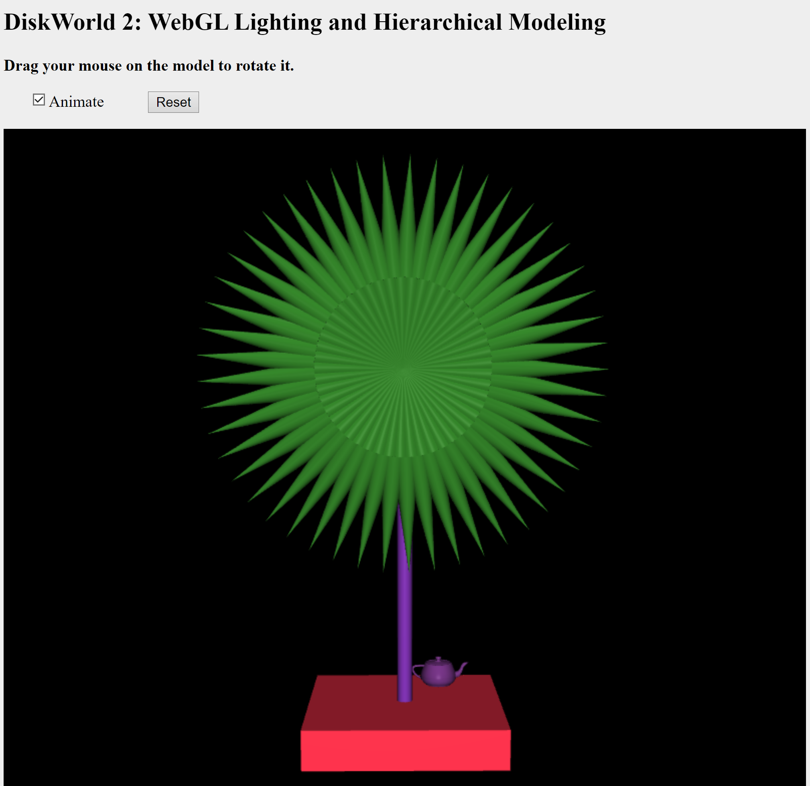

**5. Wnioski:**

Celem zadania było zapoznanie się z podstawami grafiki 3D za pomocą biblioteki WebGL/GLSL. Poprzez realizację zadania, uzyskaliśmy praktyczne doświadczenie w tworzeniu i manipulowaniu obiektami 3D oraz animacjami w środowisku WebGL.

Shader wierzchołków został zaimplementowany jako skrypt HTML, który następnie został przekształcony w kod źródłowy za pomocą funkcji getTextContent.

Głównym zadaniem było zastąpienie małego sześcianu dużym wiatrakiem, składającym się z prostokątnej podstawy oraz łopatek, które miały być zbudowane z dwóch stożków. Wszystkie obiekty na scenie zostały przekształcone z podstawowych obiektów (sześcian, stożek, cylinder) przy użyciu metod renderujących.

Łopatki wiatraka zostały zaprojektowane tak, aby obracały się po włączeniu animacji. Aby osiągnąć ten efekt, wykorzystaliśmy macierze transformacji do odpowiedniego skalowania, przesuwania i obracania obiektów.

Zadanie pozwoliło zgłębić kluczowe aspekty grafiki 3D, takie jak implementacja shaderów wierzchołków, wykorzystanie macierzy do transformacji obiektów 3D, tworzenie złożonych obiektów z prostych brył oraz implementacja animacji w WebGL. Wprowadzenie dodatkowego elementu, jakim był czajniczek na podstawie, ukazało wszechstronność i możliwości WebGL w renderowaniu grafiki 3D.